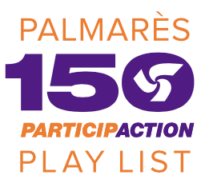

Dear parents,

We would like to invite you and your family to a fun-filled evening of physical activity!

In celebration of Canada’s 150th birthday, ParticipACTION has created an exciting program called the 150 Play List. The Play List is a crowdsourced list of 150 physical activities that define us as uniquely Canadian. The purpose of the program is to help get Canadians moving more and sitting less by encouraging them to try new sports and physical activities, with the goal of completing all 150. Throughout 2017, we sent two teams to travel across the country promoting the initiative, hosting nearly 100 events, reaching every province and territory in our great nation.

To celebrate the end of our year-long tour, we have partnered with the Girl Guides of Canada, Lougheed Area to bring the community of Coquitlam one last chance to check activities off the 150 Play List. The 150 Play List crew will showcase a large number of FREE physical activities for all ages to try. In addition to all of the physical activities onsite, there will be food and beverages, prizes, photo opportunities, free group fitness and dance classes, and guest speakers!

We are hoping that you and your family can join us in celebrating the end of an epic journey with the 150 Play List program! Come to the Percy Perry Stadium to pick up your 150 Play List passport and see how many activities you can complete!

Event details:
- What: A free friends and family-oriented community event focusing on physical activity
- Where: Percy Perry Stadium - Town Centre Park (1290 Pipeline Rd, Coquitlam, BC V3B 4S1)
- When: Thursday November 30th, 2017 from 3:30pm – 9:00pm
- Free activities to include: Surfing, hockey, kayaking, quidditch, football, slacklining, wheelchair tennis, curling and many more!

If you are interested in finding out more details or will be joining us at the event, please RSVP on the event page: www.150PlayListFinale.ca. For any questions please reach out to crew.sisley@thet1agency.com

Thank you for your time and we look forward to seeing you at the finale event!

Sincerely,

Crew Sisley

